Ewalt Volschenk

Week 8: Practical

Task 1: Create Azure Budget Alerts
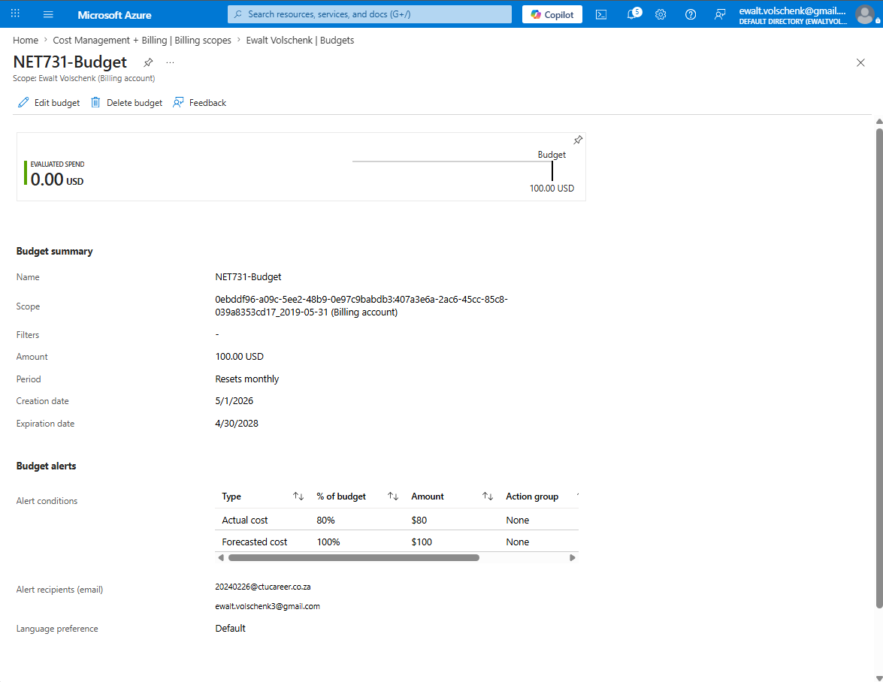

Task 2: Monitor usage and adjust a Resource

Before:
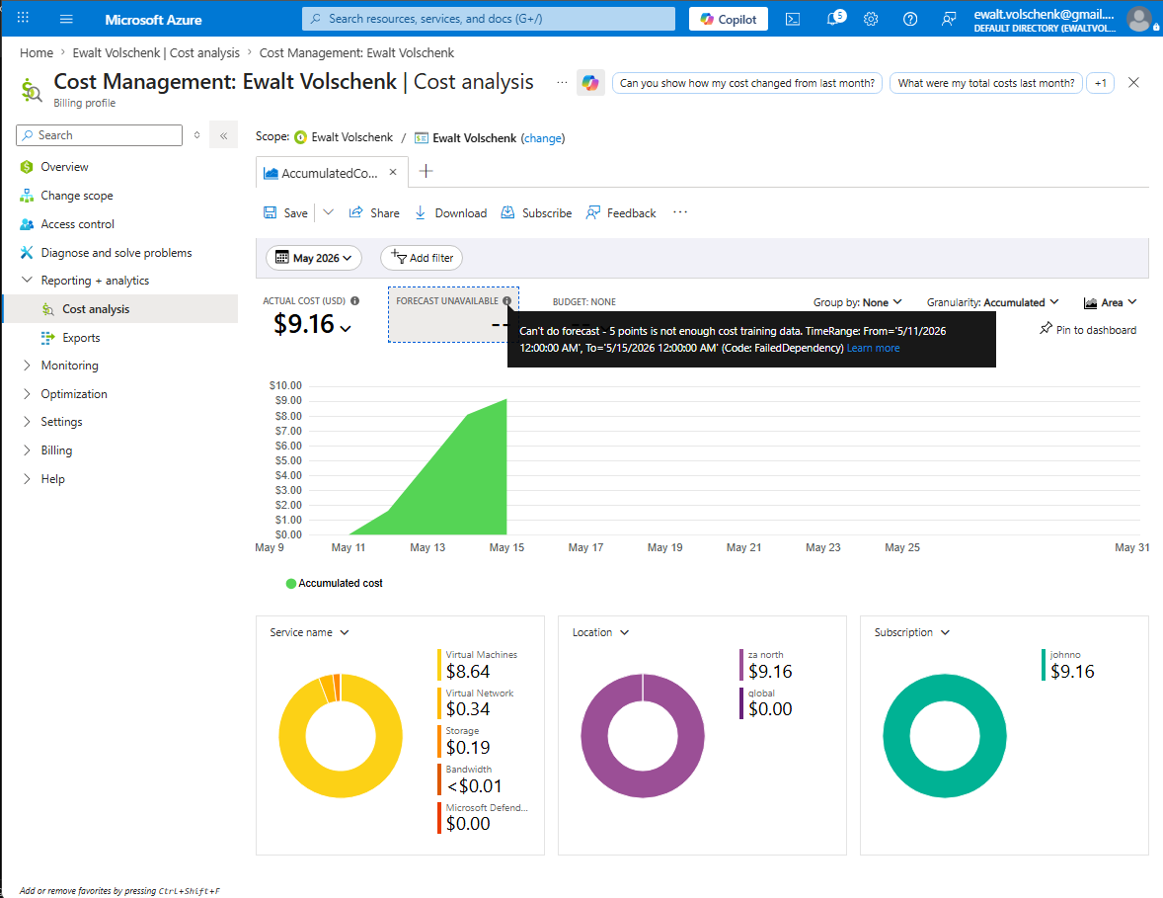

Change made: I Stopped the VM since there are no workloads currently running.
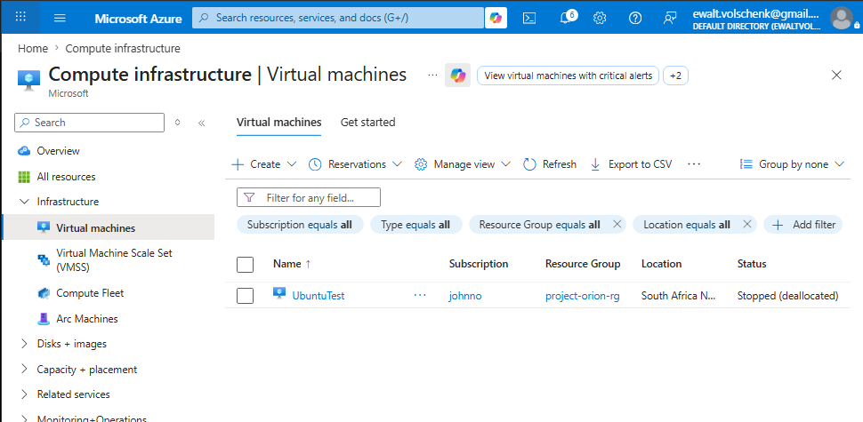

After: No Forecast available since a 10 day history is required. Manually estimated would forecast $54.90/month
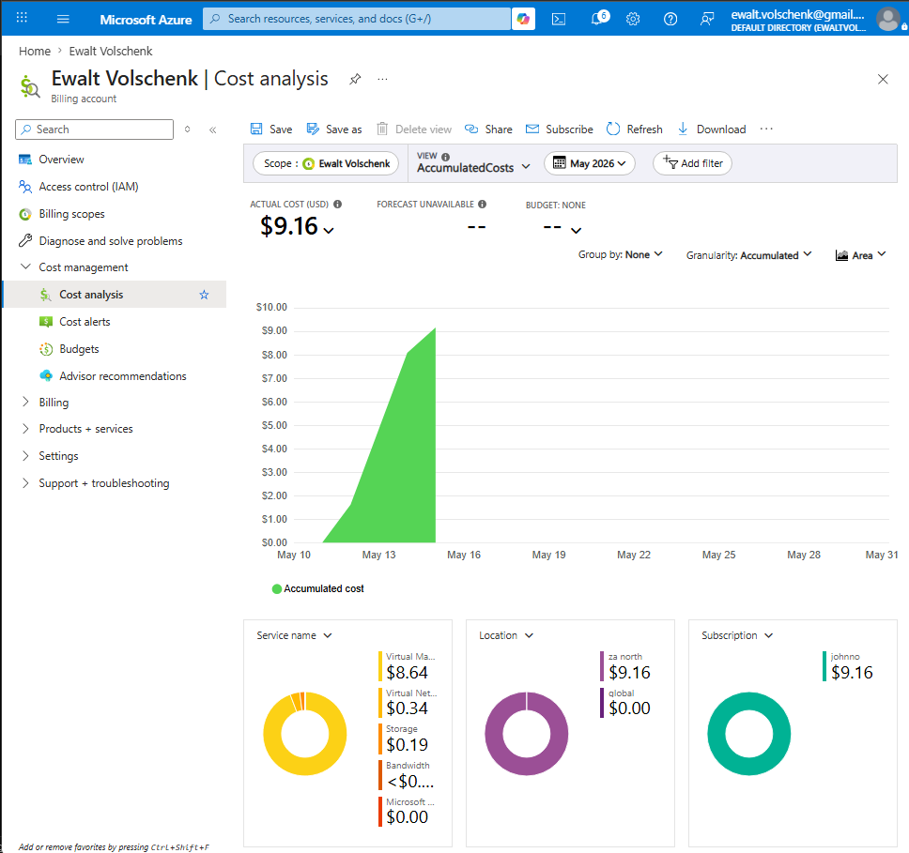

Task 3
I created a budget called NET731-budget with my subscription as the scope. The amount is $100 since that is the total free credit provided. I set up alerts for when actual costs reaches 80% of the $100 or when the forecast is 100% of the $100. My top 3 most expensive resources are my VM, the VNET for the VM and my Storage Account. In Task 2 I stopped the VM since it is sitting idle, I expect the costs to increase much slower because of this. The manually calculated forecast equates to about $54.90. For future students I would recommend managing the costs since you only get $100 free credit and it expires after one month.

